Lab 4 -Lab task – 24k0880

Task 1:
include irvine32.inc

.data
msg1 BYTE "Input A: ",0
msg2 BYTE "Input B: " ,0
msg3 BYTE "Input c: " ,0
num_a dword 0
num_b dword 0
num_c dword 0

.code
main PROC

mov edx, offset msg1
call writestring
call readint
mov num_a, eax

mov edx, offset msg2
call writestring
call readint
mov num_b, eax

mov edx, offset msg3
call writestring
call readint
mov num_c, eax

mov eax, 2
mul num_c
mov ebx, eax

mov eax, num_a
add eax, num_b

sub eax, ebx
call writeint

main endP
end main
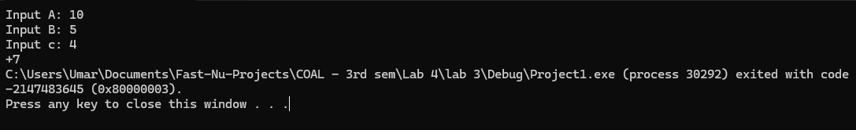

Task 2:
include irvine32.inc

base equ 10

.data
msg1 byte "area of triangle is: "

.code
main PROC
mov edx, offset msg1
call writestring

hieght = 20
mov ebx, hieght
mov eax, base
mul ebx

mov ebx, 2
div ebx
call writeint

main endP
end main

Task 3:

INCLUDE Irvine32.inc

base EQU 25000
days EQU 30
rate EQU 600

.data
msg1 BYTE "Total salary is: ", 0
msg2 BYTE "Input leaves: ", 0
msg3 BYTE "Input hours: ", 0
leaves DWORD ?
hours DWORD ?
salary DWORD ?

.code
main PROC

mov edx, OFFSET msg2
call WriteString
call ReadInt
mov leaves, eax
call Crlf

mov edx, OFFSET msg3
call WriteString
call ReadInt
mov hours, eax
call Crlf

mov eax, base
cdq
mov ecx, days
idiv ecx
imul eax, leaves
mov edx, eax

mov eax, hours
imul eax, rate
mov ecx, eax

mov eax, base
sub eax, edx
add eax, ecx
mov salary, eax

mov edx, OFFSET msg1
call WriteString
mov eax, salary
call WriteInt
call Crlf

exit
main ENDP
END main

